Writing a review
Studenti třídy 3D měli v minulém týdnu tento DÚ:
Napište recenzi na krátký film (odkaz níže) pro webovou stránku naší školy. Ta nejlepší bude zveřejněna.
Nehraje roli počet slov, ale hezký text v Aj.
https://www.youtube.com/watch?v=4Phh2D_ilPE
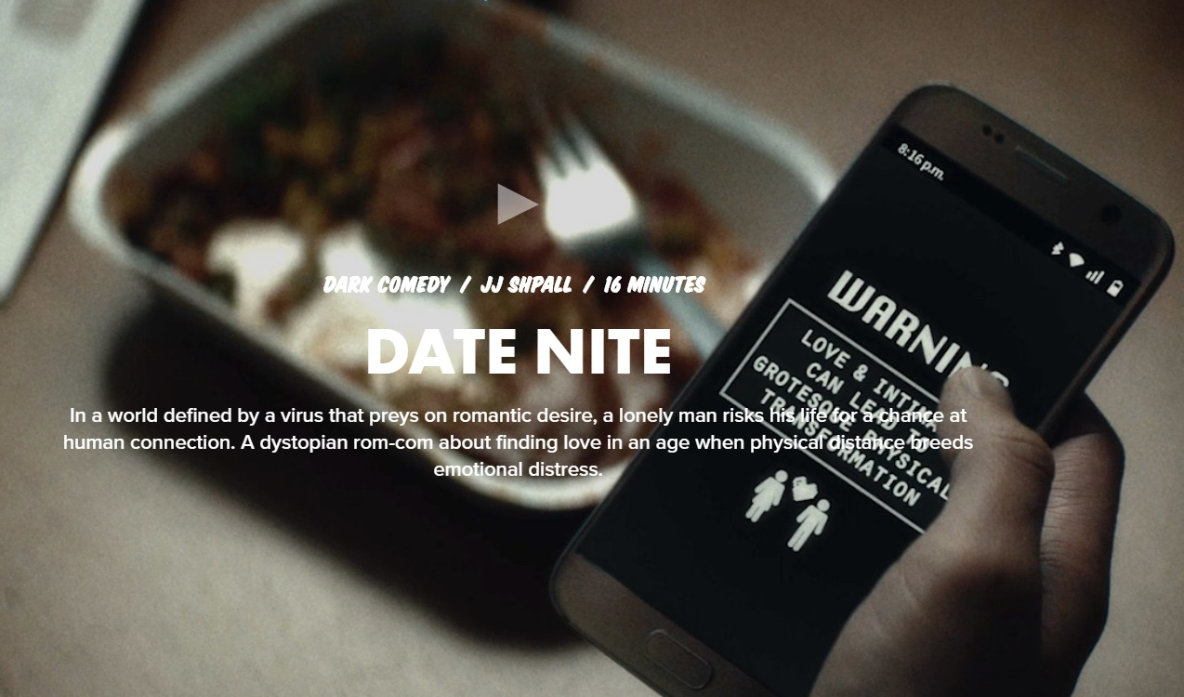
Tváří se to, že nejdou zapnout automatické titulky. Takže kdo by s tím měl problém, tak zkuste to co mají za úkol prváci: https://vimeo.com/401098593
To je beze slov, a nebo si najděte libovolný krátký film sami (do 15minut max), ale uveďte jeho celý název a do závorky i webový odkaz na něj.
Termín: do 10.5. neděle 20.00
Váha: A (10)
Enjoy!
A takhle se s tím vypořádali ti nejlepší nebo nejzajímavější, klidně se zamítavými recenzemi:
Iva
After reading Deniss review on Date Nite and teachers recommendation to watch The Kite, I watched both.
First I started with The Kite. I’m definitely not the brightest bulb, but can anyone tell me, what was the point of that short film? It was very nicely done, has beautiful music, it’s very cute, little bit sad and it’s missing a point or a plot twist. Which is a key to a good story in my opinion. It's hard to tell what kind of relationship the two main characters have or how things work in their world. Front the art sice it's nice, But for normal or typical audience it is bit too imaginitive. As a regular story it's a 3/10.
On the other hand the Date Nite is more straightforward. It seem like an episode of popular series Black Mirror. It's either paralel universe or our Future, where we have to pay for love or lust. It's a story about a man and his lonely life. Also the irony is he works in a call centrum and helps people with different forms of affection, mostly love. Overall it's a pretty interesting idea as any episode of Black Mirror. I would like to know, how they reproduce in that world, seems impossible for them, for this it's definitely 8/10.

Josef
This film is about dangers of being alone, self-isolated,... I really don’t know what the director of this film wanted to show us, but I don’t think that he did this film while being sober. I didn’t understand anything in this film, because there was a lot of weird things happening. The guy’s leg disappeared out of nowhere, just because he was alone? And then the girl’s hair start falling of? Like, what? It doesn’t make any sense. Maybe this film would be really good if I understood what it was about… Unfortunately I did not.

Radek

So I watched this short movie “Date Nite” and I would not say it was bad but I would not say it was good either. It was just average short movie with actually pretty good actors. Movie is about dangers of dating and possibly getting physically hurt by some kind of a virus.
I’d say it has pretty interesting message hidden in it. Unlike Denis I do not think it is about sacrificing something in a relationship. I believe it is about someone that has been already heartbroken and is scared to go into another relationship knowing he will probably get hurt again no matter what.
The movie could have been a bit shorter but it wasn't that bad. Overall 6/10

Denis

So i watched this short movie you sent us. Firstly i want to begin with the lenght of it. It was so long for nothing. I think that this should or would be able to shoot in 5 minutes. I mean, it was long for really nothing. Like i said, 5 mins would be enough for the massage it ment. The story itself isn't such a good idea. It is saying something like you should sacrifice something for a relationship or something like that. That is such an individual thing a it cannot be for everybody. My rating for it is like 2/10 (2 out of 10). To be honest, it's a crap.

Jediný využil možnost psát o jiném titulu David
I decided to take advantage of your offer, and decided to write a review of a short animated CGI film called “Last day of War” by Dima Fedotov, which has 6 minutes and 31 seconds and describes how, much likely, will the last war of mankind end.
This Film is really short, but that doesn’t take nothing from its atmosphere which really forces human being to stop for awhile and think.
The Animation is decent, there isn't much characters to talk about, except for one “silent” pilot and old combat computer system which really doesn’t talk much about how it feels.
Finally, I would like to borrow a phrase what I’ve found in commentary section.
It goes: “Strange that in the end, the plane saved the one thing it didn’t needed: The Pilot.”
Name: CGI 3D Animated Short Film HD: “Last day of War” - by Dima Fedotov
Link: https://www.youtube.com/watch?v=IjJmTeBSEzU

